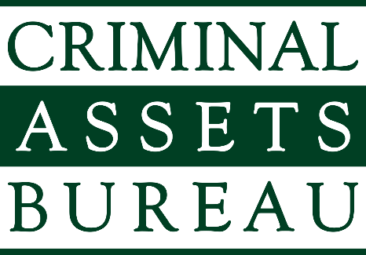 | Criminal Assets Bureau  Walter Scott House  Military Road  Dublin 8  D08 HE2P  Tel/Teileafón: +353.1.6663266  Our Reference:  Your Reference: | An Biúro um Shócmhainní Coiriúla  Teach Walter Scott  An Bóthar Míleata  Baile Átha Cliath 8  D08 HE2P  E-mail: info@cab.ie  Document No.:  Date:

Subject Access Request Form

Request for Access to Personal Data under Article 15 of the General Data Protection Regulation

PLEASE COMPLETE ALL PARTS

NOTES:
- Request in writing must be made and signed by the applicant.
- In order to respond to your request for personal data, you will need to provide us with adequate Proof of Identity.
- Where a request is manifestly unfounded, excessive, of a repetitive nature or where more than one copy of the data is sought, a fee may apply.
- You may contact our Data Protection Officer to assist you in the completion of this Form.
- If the application must be made through a solicitor, a signed form consenting to release of data to solicitor is required.
- Third party requests by parent/guardian requires their identification documents.
- A copy of our Privacy Statement is available at: cab.ie/privacy-policy-cookies/

Please complete all parts of this Form in full.
PLEASE COMPLETE ALL PARTS
Part 1 – Details of Data Subject (Your Details)

Contact Details (in block capitals):

Full Name: ___________________________________________________________________

Current Address: ___________________________________________________________________

___________________________________________________________________

___________________________________________________________________

Eircode: ____________________________________________________________

PPSN: ______________________________________________________________

Contact Phone Number: ___________________________________________________________________

Email Address (where applicable):
___________________________________________________________________

Part 2 – Details of Request

The details of my request are: To assist us in responding to your request please provide details of your interactions with the Bureau and any specific identifiers e.g. previous addresses, reference numbers, date of birth etc.

___________________________________________________________________

___________________________________________________________________

___________________________________________________________________

___________________________________________________________________

___________________________________________________________________

The time period for which the data is sought:

___________________________________________________________________

___________________________________________________________________

Any additional information that may assist in responding to your request:

___________________________________________________________________

___________________________________________________________________

___________________________________________________________________

___________________________________________________________________

___________________________________________________________________
Part 3 – Verification of Identity

In order for us to verify your identity please provide the following:

1. A copy of your photographic identification, such as:

- Current Passport
- Current Driving Licence
- Public Services Card

AND

2. A copy of a recent (within 6 months) Utility Bill or Government issued letter

Part 4 – Declaration

I declare that all the details I have provided in this form are true and complete to the best of my knowledge.

Signature of Requester: ____________________________________________

Date: ____ / ____ / ________

Please return the completed form by post or email to:

Data Protection Officer
Criminal Assets Bureau,
Walter Scott House,
Military Road, Dublin 8,
D08 PTX6, Ireland.

Email: info@cab.ie

Part 5 - Checklist

- Completed the Subject Access (SAR) Request form in full YES/NO
- Signed and dated the Declaration YES/NO
- Provided us with sufficient details to locate your personal data YES/NO
- Provided adequate Proof of Identity YES/NO
- Included letter of consent to Solicitor (where applicable) YES/NO

